GOLD PRICE PREDICTION: A STUDY ON RANDOM FOREST AND REGRESSION MODELS
A Major Project Report Submitted to
JNTUH Hyderabad in partial fulfillment of the requirements
for the award of the degree of

BACHELOR OF TECHNOLOGY
in
COMPUTER SCIENCE & ENGINEERING
(DATA SCIENCE)

By
G. KIRITI (22TK1A6712)
D.AKSHITHA (22TK1A6709)
B. SUMAN (22TK1A6703)
J. VASANTH (22TK1A6714)

Under the Guidance of
Dr. MOHAMMED YASIN ALI
Assistant Professor


DEPARTMENT OF COMPUTER SCIENCE & ENGINEERING (DATA SCIENCE ) SVS GROUP OF INSTITUTIONS
(Approved by AICTE, New Delhi & Affiliated to JNTU, Hyderabad & Accredited by NAAC,) BHEEMARAM(V), Hanamkonda T.G. India -506015

JAWAHARLAL NEHRU TECHNOLOGICAL UNIVERSITY HYDERABAD
2025-2026

SVS GROUP OF INSTITUTIONS
(Approved by AICTE, New Delhi & Affiliated to JNTU, Hyderabad, Accredited by NAAC) BHEEMARAM(V),Hanamkonda. T.G. India -506015



C E R T I F I C A T E

This is to certify that the major project work entitled “GOLD PRICE PREDICTION :
A STUDY ON RANDOM FOREST AND REGRESSION MODELS” done by
G.KIRITI (22TK1A6712),D.AKSHITHA (22TK1A6709), B.SUMAN (22TK1A6703),
J.VASANTH (22TK1A6714) students of B.Tech. Computer Science and Engineering
in the Department of Data Science, during the period 2022 to 2026 in partial fulfillment of
the requirements for the award of the degree of Bachelor of Technology in Computer
Science & Engineering from JNTUH, Hyderabad.

Dr.MOHAMMED YASIN ALI DR.A.PRATHAPA REDDY
Project Guid & H.O.D Professor & Principal

External Examiner

ACKNOWLEDGEMENT

The completion of this mini project work gives us an opportunity to convey our gratitude to all those who helped us to complete successfully.
First, we gratefully acknowledge our deep sense of gratitude to Almighty for spiritual blessings to complete the project.
We thank our parents for supporting us unconditionally throughout our project work and improve ourself doing the project, complete it submitting the thesis.
Our sincere thanks to Dr. E. THIRUMAL RAO, Chairman, SVS Group of Institutions, for providing this opportunity to carry out the Project in the Institution.
We respectable thanks to Dr. A. PRATHAPA REDDY, Professor & Principal of SVS Group of Institutions, and Project Coordinator for providing all necessary facilities and encouraging words for completion of this project.
we gratefully acknowledge Dr.MOHAMMED YASIN ALI , Assistant Professor & Head of the Department, Data science, for his encouragement and advice during the project work.
Our sincere thanks to DR. MOHAMMED YASIN ALI, Assistant Professor, Department of Data science, SVS Group of Institutions, for her continuous support during this project.
We would like to express our thanks to all the Faculty & Nonteaching faculty members and staff of the Department of Data science, SVS Group of Institutions, who have rendered valuable help in making this mini project successful.

G. KIRITI (22TK1A6712)
D.AKSHITHA (22TK1A6709)
B. SUMAN (22TK1A6703)
J. VASANTH (22TK1A6714)

INDEX
S. No. | Contents | Page No.
1 | INTRODUCTION  - Problem Definition  1.1.1 Objectives of the project  1.1.2 Existing system  1.1.3 Proposed system  1.1.4 Project description | 1
2 | SYSTEM ANALYSIS  2.1 Literature Survey  2.2 Requirement Analysis  2.2.1 Modular Description  2.2.2 Feasibility study  2.2.3 Software Requirement Specification | 7
3 | SYSTEM DESIGN  3.1 System Architecture  3.2 UML Design  3.2.1 Usecase Diagram  3.2.2 Class Diagram  3.2.3 Sequence Diagram  3.2.4 Collaboration Diagram  3.2.5 Activity Diagram | 21
4 | IMPLEMENTATION  4.1 About Software  4.1.1 Python  4.1.2 Pandas  4.1.3 Key Features of Python  4.1.4 Packages  4.2 Source Code | 30
5 | TESTING | 36
6 | RESULTS AND SCREENSHOTS | 42
7 | CONCLUSION | 47
8 | FUTURE ENHANCEMENT | 49
9 | BIBILOGRAPHY | 51

ABSTRACT

The project titled “GOLD PRICE PREDICTION : A STUDY ON RANDOM FOREST AND REGRESSION MODELS” predicts the gold EFT price based on the previous year’s gold price data. The main goal of this project is to forecast the rise and fall in the daily gold rates, that can help investors to decide when to buy or sell the gold. Inventory forecasting plays a crucial role in the financial success of the business. The price of gold is calculated by looking at the dataset that contains the previous year’s gold price.
Rise in gold value coupled with volatility and falling prices from other markets such as capital markets and real estate markets has attracted more and more investors to gold as an attractive investment. There's a fear that those high prices will be sustainable and that the prices will reverse. Although there are a number of studies that analyze the correlation between the gold price and certain economic variables. We have applied machine learning technique to predict financial variables and we have focused on predicting the gold price ETF using a linear regression algorithm as our dataset is a numerical dataset. It uses various machine learning algorithms like linear Regression, Decision Tree, and Random Forest have been used to predict the gold rates. By using different algorithms, we’ve come to a conclusion that the random forest method provides more accurate results. Keywords: Gold ETF, Machine Learning, Supervised Learning, Linear Regression, Python.

CHAPTER 1

INTRODUCTION

Gold is an integral part of our lives in India. On the global front, India is the largest consumer of gold. India accounts for more than 30 per cent of the global gold market. However, the domestic production of gold in India is minimal. India meets the high demand of gold from its domestic consumers by importing it. However, as per the statistics of Gold Council, jewellery accounts for nearly 75 per cent of the gold demand in India. It is an effective way of hedging against many unfavorable events such as unhealthy inflation, political and social crises, and anything else that could diminish the value of currency. If you buy gold bullion, it will be there until you sell it, and this feature is valuable in the eyes of investors. In addition, the value of gold has a very small price correlation with risky assets such as stocks; thus, gold is a great portfolio diversification tool. Its importance lies in reflecting the expectations of the investors, marking the trends and expectations of growth and decline of the world economies.
Gold price and Inflation go simultaneously; Besides, it is one of the most traded commodities considering its stability and potential as an investment tool. The major hypothesis in analyzing the price oscillations in different markets (goods, stocks financial markets, etc.) is the accidental nature of the market. We know that one of the reasons of gold price change is the external effects such as economic policies, environmental conditions political and social problems. One general assumption is made in such cases is that the historical data incorporate all those behaviors. As a result, the historical data is the major input to the prediction process. those are developed mainly based on different assumptions, mathematical foundations and specific model parameters. However, for better result, it is important to find the appropriate technique for a given forecasting task. In our project, we have used Time Domain analysis using Box- Jenkins methodology to forecast the monthly average gold prices for the period Jan’95 – Mar’15. In this report, first we present in detail the model and the methodology used. Then we proceed to present the mathematical formulation of the time series analysis. Finally, we present our analysis and results.

1.1 PROBLEM DEFINITION
Problem Formulation is one of the most important steps We do before starting any project. there has to be a clear idea about the goal of our data science project. In our case, the goal of this project is to analyze the price of gold. The price of gold is volatile, they change rapidly with time. Our main Aim of this project will be to predict the price of gold per unit.
1.1.1 OBJECTIVES OF THE PROJECT
The key objectives are to:
- To Develop an Accurate Predictive Model: Build a robust model that can accurately forecast short-term or long-term gold price movements.
- To Identify Key Influencing Factors: Determine which economic and market factors most significantly influence gold prices.
- To Provide Decision Support: Offer actionable insights (e.g., buy/sell signals) to investors, traders, and financial analysts to help in making datadriven investment decisions.
- To Compare ML Techniques: Evaluate and compare the performance of different machine learning algorithms to identify the most effective one for this specific task.

1.1.2 EXISTING SYSTEM
Brief overview of current methods used for gold price prediction, such as statistical models, time series analysis, and expert judgment. Discussion of the limitations of traditional approaches, including reliance on historical data, inability to capture complex relationships, and susceptibility to biases and errors. Here they used decision tree machine learning algorithm model for the gold rate prediction

Disadvantages Of Existing System
1)Lack of Interpretability in Complex Trees: While decision trees are generally interpretable, complex trees with many nodes and branches can be difficult to interpret. This can make it challenging to understand the reasoning behind the model's predictions, especially for stakeholders who are not familiar with decision tree algorithms.
2) Limited Expressiveness: Decision trees have a limited expressive power compared to other models like neural networks. They may struggle to capture complex relationships between input features and gold prices, especially if the relationships are non-linear.
3)Lack Of Accuracy: When it comes to predicting gold prices, decision trees may suffer from a lack of accuracy due to several factors. Firstly, the inherent complexity of gold price movements can pose a challenge for decision trees to capture effectively. Gold prices can be influenced by a myriad of factors including economic indicators, geopolitical events, inflation rates, and investor sentiment, among others. While decision trees can handle multiple features, their ability to discern intricate relationships among these factors might be limited, leading to less accurate predictions.
4) Overfitting: Decision trees have a tendency to overfit the training data, especially when they are deep. This means they might capture noise in the data rather than the underlying patterns, leading to poor generalization on unseen data.
1.1.3 PROPOSED SYSTEM
Introduction to Using Linear Regressor for Gold Price Prediction Gold price prediction is a complex task influenced by various factors such as economic indicators, geopolitical events, and market demand-supply dynamics. Traditional methods, like simple moving averages or rule-based systems, often fail to capture the intricate relationships among these factors. Leveraging a linear regressor can be highly effective for predicting gold prices due to its ability to handle linear relationships and interactions among features. This approach provides a systematic way to model and understand the influence of multiple predictors on gold prices.
Linear Regression: Basics and Advantages
Linear regression is a statistical method that models the relationship between a dependent variable (gold price) and one or more independent variables (features). The linear regressor aims to find the best-fitting line through the data points, minimizing the difference between the actual and predicted values. The model's simplicity allows it to be interpretable and computationally efficient, making it a good starting point for predictive analytics.

Advantages Of Proposed system
- Simplicity and Interpretability
  - Easy to Understand: Linear regression models are straightforward to understand and interpret. The relationship between the dependent variable (gold price) and the independent variables (features) is clearly defined by the coefficients.
  - Transparency: Stakeholders can easily see how different factors influence the gold price, which is crucial for decision-making and gaining insights.
- Efficiency and Speed
  - Computational Efficiency: Linear regression is computationally less intensive compared to more complex models like neural networks or ensemble methods. This makes it suitable for real-time predictions where speed is essential.
  - Quick Training: The model can be trained quickly even with large datasets, enabling faster iterations and updates as new data becomes available.
- Capability to Handle Multicollinearity
  - Regularization Techniques: Methods like Ridge and Lasso regression can be used to address multicollinearity (when independent variables are highly correlated) by adding penalties to the coefficients. This helps in improving the model's generalization performance.
- Scalability
  - Adaptable to Large Datasets: The system can handle large volumes of data efficiently, making it scalable as the dataset grows over time.
  - Extensible to Multiple Features: It can incorporate a wide range of features, including economic indicators, historical prices, and market sentiment data, without becoming overly complex.
- Flexibility in Feature Engineering
  - Customizable Features: The system allows for the creation of new features and interaction terms that can capture the nuanced relationships between different predictors and the gold price.
  - Time Series Adaptation: By incorporating lagged values, rolling averages, and other time series features, the model can effectively account fortemporal dependencies in the data.
- Effective Handling of Overfitting
  - Regularization: Techniques like Ridge and Lasso regression help prevent overfitting by constraining the coefficients. This leads to better performance on unseen data and ensures the model does not capture noise.
  - Cross-Validation: Employing cross-validation techniques ensures the model is validated on different subsets of the data, improving its robustness and reliability.
- Robust Evaluation
  - Comprehensive Metrics: The use of various performance metrics such as Mean Absolute Error (MAE), Mean Squared Error (MSE), and R-squared allows for a thorough evaluation of the model's accuracy and effectiveness.
  - Residual Analysis: By analyzing the residuals, the model's shortcomings can be identified and addressed, ensuring no significant patterns are left unexplained.
- Foundation for Advanced Methods
  - Baseline for Complex Models: Linear regression can serve as a baseline model. If more complex patterns are identified, the system can be extended to include advanced methods like polynomial regression, decision trees, or ensemble models.
  - Incremental Improvements: Starting with a linear model allows for incremental improvements, testing and validating each step before moving on to more sophisticated approaches.

1.1.4 PROJECT DESCRIPTION
Our project aims to develop a robust machine learning model for predicting gold prices.Leveraging historical gold price data and relevant features such as economic indicators, market sentiment, and geopolitical events, we will employ advanced machine learning algorithms to forecast future gold prices with high accuracy. The project will involve extensive data preprocessing, including cleaning, normalization, and feature engineering to ensure the quality and relevance of input data. Various machine learning techniques such as regression, time series analysis, and ensemble methods will be explored and compared to identify the most effective approach for gold price prediction. Additionally, we will implement model evaluation strategies such as crossvalidation and backtesting to assess performance and refine the predictive capabilities of the system.The ultimate goal is to create a reliable tool that can assist investors, financial analysts, and policymakers in making informed decisions in the volatile gold market. In our project on gold price prediction using machine learning, we embark on a comprehensive analysis of factors influencing gold prices and their predictive potential. By harnessing cuttingedge machine learning techniques, we aim to construct a predictive model that can anticipate fluctuations in gold prices with precision. Our methodology encompasses a multi-stage process, beginning with data collection from diverse sources spanning economic indicators, global market trends, and geopolitical developments. Through meticulous data preprocessing and feature selection, we curate a high-quality dataset primed for modeling. Next, we delve into the realm of machine learning, experimenting with an array of algorithms tailored to time series forecasting and regression tasks. From traditional linear models to more sophisticated ensemble methods and neural networks, we scrutinize their performance against historical gold price data. Employing rigorous validation techniques, including cross-validation and out-of-sample testing, we iterate on model architecture and hyperparameters to optimize predictive accuracy.

Chapter 2
2.SYSTEM ANALYSIS
2.1 Literature Survey
S.No | Author / Year | Model / Method Used | Application / Study | Key Findings
1 | Christodoulos et al., 2010 | Box-Jenkins Model | Time series forecasting | Box-Jenkins modeling is a powerful forecasting technique used to analyze different types of time series data.
2 | Shafiee and Topal, 2010 | ARMA Model | Gold price analysis | Gold prices show random walk behavior and non-stationary characteristics.
3 | Khashei et al., 2009 | ARMA Model | Financial market forecasting | ARMA provides accurate short-term forecasting and is easy to implement.
4 | Wang et al., 2005 | ARMA-GARCH Model | Daily stream flow forecasting | Proposed a hybrid model to capture ARCH effects in time series data.
5 | Zou et al., 2006 | ARIMA-GARCH Model | Internet traffic forecasting | Hybrid ARIMA-GARCH model improved prediction accuracy.
6 | Chen et al., 2011 | ARIMA-GARCH Model | Traffic flow prediction | Model effectively predicted short-term traffic flow patterns.
7 | Yuan, 2012 | Back Propagation Neural Network | Gold price forecasting | Neural networks can capture nonlinear patterns in financial data.
8 | Zhou et al., 2012 | Back Propagation Neural Network | Financial prediction | Neural networks improved prediction performance.
9 | Tharmmaphornphilas et al., 2012 | System Dynamics Model | Commodity forecasting | Used system dynamics to analyze complex market behavior.
10 | Zhang et al., 2011 | Varying-Coefficient Regression Model | Gold price analysis | Model captures dynamic relationships between variables.
11 | Mustaffa & Yusof, 2011 | Data Mining Techniques | Gold price prediction | Data mining helps discover hidden patterns in financial datasets.
12 | Ismail et al., 2009 | Multiple Linear Regression | Financial forecasting | Regression models analyze relationships between multiple variables.
13 | Hadavandi et al., 2010 | Hybrid Forecasting Model | Gold price prediction | Hybrid models improve forecasting accuracy compared to single models.
14 | Asadi et al., 2012 | Hybrid Models | Time series forecasting | Combining models helps overcome limitations of individual methods.

2.2 REQUIREMENT ANALYSIS

1.Data Collection and Preprocessing: Determine the sources of historical gold price data and other relevant features such as economic indicators, market sentiment indices, and geopolitical events. Assess the quality of data, including accuracy, completeness, and consistency. Develop strategies for cleaning, normalization, and feature engineering to prepare the data for modeling.

2.Feature Selection and Engineering: Identify the most influential features for gold price prediction through statistical analysis, domain knowledge, and correlation studies. Explore techniques for feature transformation, dimensionality reduction, and creating lagged variables to capture temporal dependencies in the data.

3.Model Selection and Evaluation: Evaluate various machine learning algorithms suitable for time series forecasting and regression tasks, such as linear regression, ARIMA, SARIMA, LSTM, and gradient boosting models. Compare the performance of models using appropriate evaluation metrics such as mean squared error (MSE), mean absolute error (MAE), and coefficient of determination (R-squared). Employ techniques like cross-validation, train-test splits, and backtesting to ensure robustness and generalization capability of the models.

- Model Interpretability and Explainability: Assess the interpretability of selected models to understand the underlying factors driving gold price movements. Explore techniques such as feature importance analysis, partial dependence plots, and SHAP (SHapley Additive exPlanations) values to interpret the impact of individual features on predictions.

- Scalability and Performance: Consider the scalability of the prediction system to handle large volumes of data efficiently. Evaluate computational requirements, model training times, and resource constraints to ensure scalability and performance optimization.

- Integration and Deployment: Plan for the integration of the prediction system with existing workflows, trading platforms, or financial applications. Determine deployment strategies, such as cloud-based solutions, containerization, or on-premises installations, considering security, reliability, and regulatory compliance requirements.

- Monitoring and Maintenance: Define metrics and thresholds for monitoring the performance of the prediction system in real-time. Establish protocols for model retraining, updating, and recalibration to adapt to changing market conditions and data dynamics.

- Ethical and Legal Considerations: Address ethical considerations regarding data privacy, bias mitigation, and responsible use of predictive analytics. Ensure compliance with relevant regulations and industry standards, such as GDPR (General Data Protection Regulation) and financial regulations governing algorithmic trading.

2.3 Modular Description
Certainly! Here's a modular description for gold price prediction, organized into data collection, data preprocessing, exploratory data analysis (EDA), model implementation, and prediction.

2.3.1Data Collection
Data collection is the process of gathering and measuring information from countless different sources. In order to use the data, we collect to develop practical artificial intelligence (AI) and deep learning solutions, it must be collected and stored in a way that makes sense for the business problem at hand.Here, I can collect the data in CSV File format in Kaggle website. Kaggle website is a open source website to download or access any other data for student Purpose.

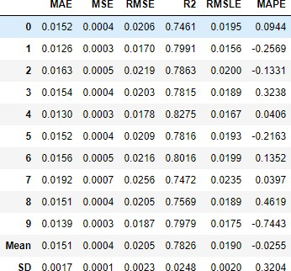
Fig:2.1 Historical Dataset of goldprice

2.3.2 Data Preprocessing

Once the data is collected, it undergoes preprocessing to clean and prepare it for analysis.This involves handling missing values, removing outliers, and encoding categorical variables if necessary. Additionally, feature scaling or normalization may be applied to ensure that all features contribute equally to the predictive model. Data preprocessing aims to improve the quality and consistency of the dataset, making it suitable for training machine learning models.

Raw

Data

Observable

Data

Data

Cleaning

&

Noise

Reduction

Raw

Data

Data

processing

Fig:2.2 Data preprocessing

2.3.3 EDA Analysis
Exploratory Data Analysis (EDA) is an approach to analyze the data using visual techniques. It is used to discover trends, patterns, or to check assumptions with the help of statistical summary and graphical representations.EDA is primarily used to see what data can reveal beyond the formal modeling or hypothesis testing task and provides a provides a better understanding of data set variables and the relationships between them. It can also help determine if the statistical techniques you are considering for data analysis are appropriate.

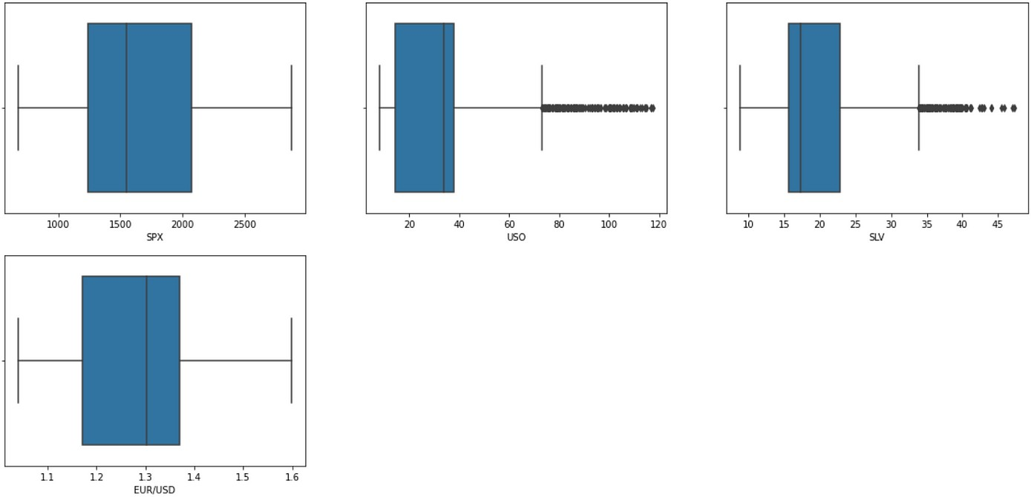
Fig:2.3.1 Data analysis
2.3.4 Model Implementation

After preprocessing and EDA, the next step is to implement machine learning models for gold price prediction. This involves selecting appropriate algorithms such as linear regression, decision trees, or random forests based on the characteristics of the data and the desired predictive accuracy. The selected model is trained on the preprocessed dataset using techniques such as crossvalidation to optimize hyperparameters and assess model performance. Model implementation may also involve feature engineering to create new predictors or transform existing ones to improve predictive performance.

2.3.4.1 Linear Regression:

Linear Regression is a fundamental machine learning method used for predicting a continuous target variable based on one or more predictor variables. The model establishes a linear relationship between the target variable and the predictors by fitting a straight line (in the case of simple linear regression) or a hyperplane (in the case of multiple linear regression) that minimizes the sum of the squared differences between the observed values and the values predicted by the model. This method is straightforward and interpretable, making it a widely used technique for regression tasks. Linear Regression performs well when the relationship between the variables is approximately linear and when multicollinearity and outliers are appropriately managed.

2.3.4.2 Regression with Linear Regression:

Linear Regression is specifically designed for regression tasks, where the target variable is continuous. During training, the model learns to predict the target variable based on the features of the input data by fitting a linear equation to the observed data. The final prediction made by the linear regression model is determined by applying the learned linear relationship to the input features, resulting in a single predicted value for the target variable.

2.3.4.3 Key Hyperparameters:

n_estimators: The number of decision trees in the random forest. Increasing the number of trees generally improves performance but also increases computational cost.
max_depth: The maximum depth of each decision tree. Controlling the depth helps prevent overfitting by limiting the complexity of individual trees.
min_samples_split:The minimum number of samples required to split an internal node. Increasing this parameter prevents overfitting by requiring more samples for a split.
min_samples_leaf:The minimum number of samples required to be at a leaf node. Similar to min_samples_split, this parameter controls the minimum size of leaf nodes to prevent overfitting.

2.3.4.4 Advantages of LinearRegressor:

- LinearRegressor is robust to overfitting and performs well on a wide range of datasets.
It can handle both numerical and categorical features without the need for feature scaling or one-hot encoding.
- LinearRegressor provides feature importance scores, allowing users to interpret the relative importance of different features in making predictions. - It is relatively easy to use and requires minimal hyperparameter tuning compared to other complex algorithms.

2.3.4.5 Applications of LinearRegressor:
- LinearRegressor is used in various regression tasks, including but not limited to:
Predicting house prices based on features such as size, location, and amenities.
- Forecasting stock prices based on historical market data and economic indicators.
- Estimating demand for products based on sales data, marketing efforts, and external factors.
- Overall, LinearRegressor is a versatile and effective algorithm for regression tasks, offering robust performance, interpretability, and ease of use. It is widely used in both academic research and practical applications across various domains

2.3.5 Prediction
Once the model is trained and validated, it can be used to make predictions on unseen data. The trained model takes as input the relevant features for a given time period and outputs the predicted gold prices. Predictions can be evaluated using appropriate metrics such as mean squared error or R-squared to assess the model's accuracy and reliability. Additionally, visualizations such as time series plots or prediction intervals can provide insights into the model's performance and potential areas for improvement.

2.4 Feasibility Study

Conducting a feasibility study for a gold price prediction project involves assessing various factors to determine the viability and potential success of the endeavor. Firstly, the availability and quality of historical gold price data, as well as relevant features such as economic indicators and geopolitical events, need evaluation. This includes examining the accessibility of data sources and ensuring their reliability, completeness, and timeliness. Secondly, the feasibility study should scrutinize the technological infrastructure and expertise required for data collection, preprocessing, and model development. Assessing the availability of skilled personnel proficient in machine learning, statistical analysis, and financial modeling is crucial. Thirdly, consideration should be given to the predictive capabilities of machine learning algorithms in forecasting gold prices.
Exploratory analysis and pilot studies can help gauge the performance of different models and identify the most suitable approaches for the task. Additionally, the feasibility study should address scalability, computational requirements, and potential regulatory and ethical implications associated with deploying a predictive model in the financial industry. By thoroughly evaluating these factors, stakeholders can make informed decisions regarding the feasibility and viability of a gold price prediction project, laying the groundwork for its successful implementation and utilization in real-world scenarios.
A feasibility study is an essential step in evaluating the practicality and potential success of a proposed project or business venture. It assesses various aspects such as technical, economic, legal, and operational factors to determine whether the project is viable and worth pursuing.

Here's an outline for a feasibility study:
1. Executive Summary
- Brief overview of the proposed project or business venture.
- Summary of key findings and recommendations from the feasibility study.
2. Introduction
- Background information on the project or business idea.
- Purpose and objectives of the feasibility study.
- Scope and methodology of the study.
3. Market Feasibility Analysis Market Analysis:
- Size and growth potential of the target market.
- Identification of target customers and their needs.
- Analysis of market trends, competitors, and potential barriers to entry.
Demand Analysis:
- Estimation of demand for the proposed product or service.
- Assessment of factors influencing demand, such as demographics,consumer preferences, and purchasing power.
Supply Analysis:
- Evaluation of existing suppliers and their capacity to meet demand.
- Identification of potential suppliers and any supply chain risks.
4.Technical Feasibility Analysis Product or Service Description:
- Detailed description of the proposed product or service.
- Assessment of technical specifications, features, and functionalities.
Technology Requirements:
- Evaluation of technology infrastructure and resources required for project implementation.
- Identification of potential technical challenges and solutions.
Development Plan:
- Timeline for product development, testing, and implementation.
- Resource requirements, including personnel, equipment, and facilities.
5. Financial Feasibility Analysis Cost Estimation:
- Breakdown of project costs, including initial investment, operational expenses,and maintenance costs.
Identification of fixed and variable costs.
Revenue Projections:
- Forecasting potential revenue streams based on market demand and pricing strategy.
- Sensitivity analysis to assess the impact of different revenue scenarios.
Investment Appraisal:
- Calculation of key financial metrics, such as Net Present Value (NPV), Internal Rate of Return (IRR), and Payback Period.
- Assessment of project profitability and investment attractiveness.
6. Legal and Regulatory Feasibility Analysis Legal Requirements:
- Identification of legal and regulatory requirements applicable to the project or business venture.
- Assessment of compliance risks and potential legal challenges.
Intellectual Property:
- Evaluation of intellectual property rights, including patents, trademarks, and copyrights.
- Protection strategies to safeguard intellectual property assets.
7. Operational Feasibility Analysis Operational Plan:
- Description of operational processes, workflows, and organizational structure.
- Identification of key personnel and their roles and responsibilities.
Resource Management:
- Assessment of resource availability, including human resources, raw materials.
- Capacity planning to ensure efficient resource utilization.
8. Risk Analysis
- Identification of potential risks and uncertainties associated with the project.
- Risk assessment and prioritization based on likelihood and impact.
- Mitigation strategies to manage and minimize risks throughout the project.
9. Conclusion and Recommendations
- Summary of key findings from the feasibility study.
- Recommendations regarding the viability and feasibility of the proposed project.
Next steps and actions required to proceed with the project, including any further research or analysis needed.
10. Appendices
- Supporting documentation, data sources, and additional information referenced in the feasibility study.Financial statements, market research reports, technical specifications, and legal documents.
Functional Requirements:
User Authentication:
- Users must be able to register for an account.
- Users must be able to log in securely using their credentials.
- The system must support password reset functionality.
Profile Management:
- Users should be able to update their profile information.
- Users should have the option to upload a profile picture.
Content Management:
- Admins should be able to add, edit, and delete content.
- Users should be able to view and interact with content based on their permissions.

2.5 SYSTEM REQUIREMENT SPECIFICATION

2.5.1 Software Interface

Operating System : Windows 7,8,10(64 bit)
Software : Python
Tools : Anaconda (Jupyter notebook IDE)

2.5.2 Hardware Interface
Hard Disk : 500GB and above
RAM : 4GB and above
Processor : 15 and above

2.5.3 Functional Requirements for gold price prediction:

Data Collection: The system should be able to gather historical gold price data from various reliable sources such as financial databases, APIs, or websites. Data Preprocessing: It should preprocess the collected data to handle missing values, outliers, and inconsistencies, ensuring data quality.
Feature Selection: The system should identify relevant features (e.g., economic indicators, geopolitical events) that may influence gold prices and select them for analysis.
Model Training: It should train machine learning or statistical models using historical data to predict future gold prices accurately.
Prediction Generation: The system should generate predictions of future gold prices based on the trained models.
Performance Evaluation: It should assess the accuracy and reliability of the prediction models through metrics such as Mean Absolute Error (MAE) or Root Mean Square Error (RMSE).
Integration: The prediction system should be integrated into a user-friendly interface, allowing users to access the predictions conveniently.

2.5.4 Non Functional Requirements For Gold Price Prediction:

Accuracy: The prediction model should achieve a high level of accuracy to provide reliable forecasts.
Scalability: The system should be scalable to handle large volumes of data and increasing computational demands as the user base grows.
Performance: The prediction process should be fast and efficient, providing timely forecasts to users.
Reliability: The system should be robust and dependable, capable of handling unexpected errors or disruptions without significant downtime.
Security: The system should implement measures to protect sensitive data, ensuring confidentiality and integrity throughout the prediction process. Usability: The user interface should be intuitive and easy to use, catering to users with varying levels of technical expertise.
Adaptability: The system should be adaptable to changes in market dynamics, allowing for continuous updates and improvements to the prediction models. Compliance: The system should comply with relevant regulations and ethical guidelines governing financial forecasting and data usage.

Chapter 3

3.SYSTEM DESIGN

3.1 System Architecture

The system architecture for a gold price prediction using machine learning project typically involves several components interconnected in a systematic manner. At the core lies the dataset collection and preprocessing stage, where historical gold price data is gathered and prepared for analysis. Following this, feature engineering may be employed to extract relevant features that could influence gold prices. These features are then fed into various machine learning models, such as regression, ensemble methods, or neural networks, to learn the underlying patterns and relationships within the data. The trained models are then evaluated using metrics like mean squared error or mean absolute error to assess their performance. Deployment of the chosen model involves integrating it into a user interface or application where real-time or future gold price predictions can be made based on new data inputs. Finally, the system incorporates mechanisms for monitoring and updating the model to ensure its continued accuracy and relevance over time.

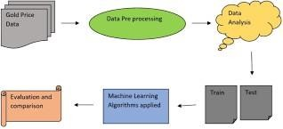
Fig:3.1 , system architecture
3.2 Data Flow Diagram

Start

Connect

The

Dataset
To Dataframe

Training Dataset

Data Preparation

Testing Dataset

Stop

Spliti
g

The

Data

Predict Gold

EFT Price

Create a

Linear Regression
Model

Fig:3.2, Data flow diagram

3.3 UML Diagrams

UML (Unified Modeling Language) is a standard language for specifying, visualizing, constructing, and documenting the artifacts of software systems. UML was created by the Object Management Group (OMG) and UML 1.0 specification draft was proposed to the OMG in January 1997. It was initially started to capture the behavior of complex software and non-software system and now it has become an OMG standard. This tutorial gives a complete understanding on UML.
UML is a standard language for specifying, visualizing, constructing, and documenting the artifacts of software systems.
UML was created by the Object Management Group (OMG) and UML 1.0 specification draft was proposed to the OMG in January 1997.
OMG is continuously making efforts to create a truly industry standard.
UML stands for Unified Modeling Language.
UML is different from the other common programming languages such as C++, Java, COBOL, etc.
UML is a pictorial language used to make software blueprints.
UML can be described as a general-purpose visual modeling language to visualize, specify, construct, and document software system.
Although UML is generally used to model software systems, it is not limited within this boundary. It is also used to model non-software systems as well. For example, the process flow in a manufacturing unit, etc.
UML is not a programming language but tools can be used to generate code in various languages using UML diagrams. UML has a direct relation with object- oriented analysis and design. After some standardization, UML has become an OMG standard.

Components of the UML

UML diagrams are the ultimate output of the entire discussion. All the elements, relationships are used to make a complete UML diagram and the diagram represents a system. The visual effect of the UML diagram is the most important part of the entire process. All the other elements are used to make it complete.
UML includes the following nine diagrams, the details of which are described in the subsequent chapters.
- Class diagram
- Object diagram
- Use case diagram
- Sequence diagram
- Collaboration diagram
- Activity diagram
- State chart diagram
- Deployment diagram
- Component diagram

The following are the main components of uml: -
- Use-case Diagram
- Class Diagram
- Sequence Diagram
- Activity Diagram
- Collaboration Diagram

3.3.1 Usecase Diagram

A use case diagram in the Unified Modeling Language (UML) is a type of behavioral diagram defined by and created from a Use-case analysis. Its purpose is to present a graphical overview of the functionality provided by a system in terms of actors, their goals (represented as use cases), and any dependencies between those use cases. The main purpose of a use case diagram is to show what system functions are performed for which actor. Roles of the actors in the system can be depicted.
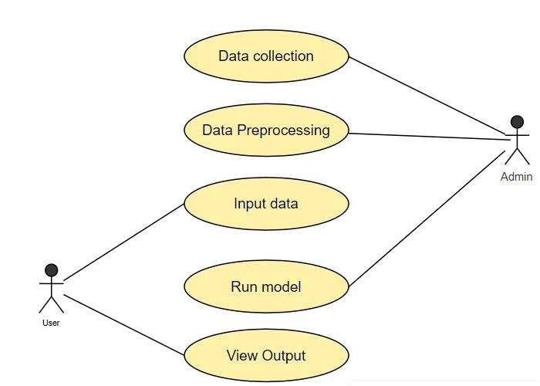
Fig:3.3.1, use case diagram

3.3.2 Class Diagram

In software engineering, a class diagram in the Unified Modeling Language (UML) is a type of static structure diagram that describes the structure of a system by showing the system's classes, their attributes, operations (or methods), and the relationships among the classes. It explains which class contains information.

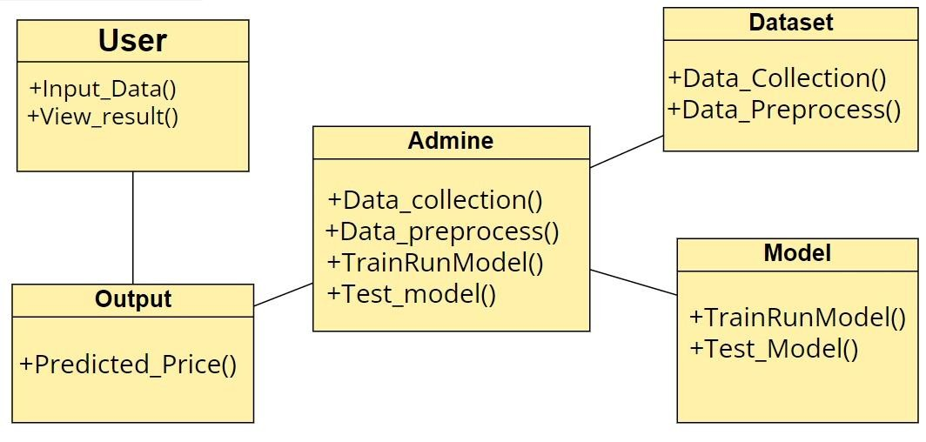
Fig:3.3.2, class diagram

3.3.3 Sequence Diagram

A sequence diagram in Unified Modeling Language (UML) is a kind of interaction diagram that shows how processes operate with one another and in what order. It is a construct of a Message Sequence Chart. Sequence diagrams are sometimes called event diagrams, event scenarios, and timing diagrams.

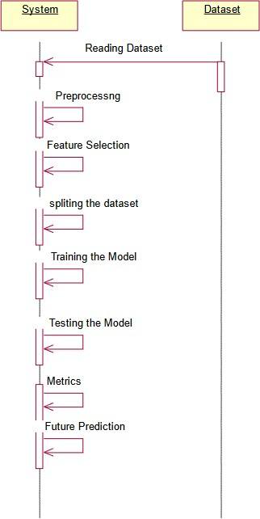

Fig:3.3.3, sequence diagram

3.3.4 Activity Diagram

Activity Diagrams are used to illustrate the flow of control in a system and refer to the steps involved in the execution of a use case. We can depict both sequential processing and concurrent processing of activities using an activity diagram i.e. an activity diagram focuses on the condition of flow and the sequence in which it happens.
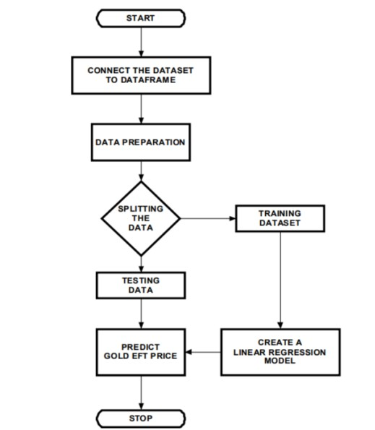
Fig:3.3.4, Activity Diagram

3.3.5 Collaboration Diagram

A collaboration diagram, within the Unified Modeling Language (UML), is a behavioral diagram which is also referred to as a communication diagram, it illustrates how objects or components interact with each other to achieve specific tasks or scenarios within a system.

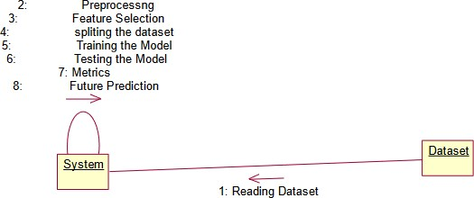

Fig:3.3.5, collaboration diagram

Chapter 4

4. IMPLEMENTATION

4.1 ABOUT SOFTWARE
4.1.1 Python:
Python is a high-level, interpreted programming language known for its simplicity, readability, and versatility. It was created by Guido van Rossum and first released in 1991. Python has gained immense popularity across various domains due to its ease of use, extensive standard library, and vibrant ecosystem of third-party libraries and frameworks. Here's an overview of Python's features and its applications, with a focus on its usefulness in developing machine learning applications.Python is a general-purpose programming language designed to be easy to learn and use.It emphasizes readability and simplicity, with clear and concise syntax that resembles pseudocode.Python supports multiple programming paradigms, including procedural, object-oriented, and functional programming.

4.1.2 Pandas:
Pandas is an open-source Python Library providing high-performance data manipulation and analysis tool using its powerful data structures. The name Pandasis derived from the word Panel Data – an Econometrics from Multidimensional data.In 2008, developer Wes McKinney started developing pandas when in need of high performance, flexible tool for analysis of data. Prior to Pandas, Python was majorly used for data mining and preparation. It had very little contribution towards data analysis. Pandas solved this problem. Using Pandas, we can accomplish five typical steps in the processing and analysis of data, regardless of the origin of data — load, prepare, manipulate, model, and analyze. Python with Pandas is used in a wide range of fields including academic and commercial domains including finance, economics,
Statistics, analytics, etc.

4.1.3 Key Features Of Pandas:
- Fast and efficient Data Frame object with default and customized indexing.
- Tools for loading data into in-memory data objects from different file formats.
- Data alignment and integrated handling of missing data.
- Reshaping and pivoting of date sets.
- Label-based slicing, indexing and subsetting of large data sets.
- Columns from a data structure can be deleted or inserted.
- Group by data for aggregation and transformations.
- High performance merging and joining of data.
- Time Series functionality.

4.1.4 Packages:

4.1.4.1 NumPy:
NumPy is a general-purpose array-processing package. It provides a high- performance multidimensional array object, and tools for working with these arrays. It is the fundamental package for scientific computing with Python. It contains various features including these important ones:
- A powerful N-dimensional array object
- Sophisticated (broadcasting) functions
- Useful linear algebra, Fourier transform, and random number capabilities 24
- Besides its obvious scientific uses, NumPy can also be used as an efficientmulti- dimensional container of generic data. Arbitrary datatypes can be defined using NumPy which allows NumPy to seamlessly and speedily integrate with a wide variety of databases.

4.1.4.2Sckit-Learn:
- Simple and efficient tools for data mining and data analysis
- Accessible to everybody, and reusable in various contexts
- Built on NumPy, SciPy, and matplotlib
- It offers a wide range of supervised and unsupervised learning algorithms,including classification,regression,clustering,dimensionality reduction,and model selection.
- Scikit-learn’s API is consistent and easy to use,making it accessible to beginners while offering advanced features for experienced users.
- Scikit-learn is built on top of Numpy,Scipy,and Matplotlib,making it seamlessly integrate with other scientific computing libraries in the Python ecosystem.
- Scikit-learn is a popular machine learning library for Python,providing simple and efficient tools for data mining and data analysis.
_{4.1.4.5} Libraries used:
- Sklearn : Machine Learning library that helps in making ML models
- Matplotlib : Used for plotting intuitive charts.
- Pandas : Import and manage datasets.
- Numpy : A mathematical Library.
- Future : getting accustomed to incompatible changes that are used in the future releases.
4.1.4.6 Matploit lib:
- Matplotlib is a python library used to create 2D graphs and plots by usingpython scripts.
- It has a module named pyplot which makes things easy for plotting by providing feature to control line styles, font properties, formatting axes etc.
- It supports a very wide variety of graphs and plots namely - histogram, barcharts, power spectra, error charts etc.

4.1.4.7 Seaborn:
Seaborn is a statistical data visualization library built on top of Matplotlib.It provides a high-level interface for creating attractive and informative statistical graphics.Seaborn simplifies the process of creating complex visualizations by providing functions for common statistical plots, such as scatter plots, box plots, violin plots, pair plots,and heatmaps.Seaborn's default styles and color palettes are aesthetically pleasing and can be easily customized to suit specific preferences.It also integrates well with Pandas DataFrames, making it easy to visualize relationships between variables in structured data.
These libraries form the backbone of the Python ecosystem for data science and machine learning, providing essential tools and functionalities for data manipulation, visualization, analysis, and modeling. Combining these libraries allows data scientists and machine learning practitioners to perform end-to-end data analysis workflows efficiently and effectively.

4.2 Source Code:

# gold_price_prediction.py

import pandas as pd
import numpy as np
import matplotlib.pyplot as plt
from sklearn.model_selection import train_test_split
from sklearn.linear_model import LinearRegression
from sklearn.metrics import mean_absolute_error, r2_score

# Load dataset
data = pd.read_csv("gold_price.csv")

# Convert Date column to datetime
data['Date'] = pd.to_datetime(data['Date'])

# Sort by Date
data = data.sort_values('Date')

# Feature Selection
X = data[['Open', 'High', 'Low', 'Volume']]
y = data['Close']

# Split dataset
X_train, X_test, y_train, y_test = train_test_split(
X, y, test_size=0.2, random_state=42
)

# Create model
model = LinearRegression()

# Train model
model.fit(X_train, y_train)

# Predictions
y_pred = model.predict(X_test)

# Model Evaluation
mae = mean_absolute_error(y_test, y_pred)
r2 = r2_score(y_test, y_pred)

print("Model Performance:")
print("Mean Absolute Error:", mae)
print("R2 Score:", r2)

# Plot Actual vs Predicted
plt.figure(figsize=(10,5))
plt.plot(y_test.values, label='Actual')
plt.plot(y_pred, label='Predicted')
plt.legend()
plt.title("Gold Price Prediction")
plt.show()

# Predict new data
new_data = np.array([[1900, 1910, 1895, 120000]])
predicted_price = model.predict(new_data)

print("Predicted Gold Close Price:", predicted_price[0])

Chapter 5
5.TESTING

Testing plays a crucial role in ensuring the accuracy reliability, and robustness of LSTM-based weather forecasting systems. Various types of testing can be conducted throughout the development lifecycle to validate different aspects of the system

5.1 Unit Testing:
Unit testing for a gold price prediction project utilizing machine learning involves verifying the functionality of individual components, ensuring they perform as expected in isolation. Each unit, such as data preprocessing, feature engineering, model training, and prediction, undergoes rigorous testing. For data preprocessing, tests confirm correct handling of missing values, data scaling, and encoding categorical variables.By conducting unit tests comprehensively, developers can enhance the reliability and maintainability of the gold price prediction system, facilitating its deployment and integration into broader applications. Conducting tests on individual components or modules in isolation.Using frameworks like JUnit, pytest, or Mocha.

5.2 Integration Testing:
Verifying the interactions and interfaces between integrated components.Testing the integration of multiple units or modules. Integration testing for a gold price prediction project utilizing machine learning is crucial for ensuring the accuracy and reliability of the system. This process involves testing the integration of different components, including data ingestion, preprocessing, model training, prediction generation, and result visualization.

5.3 System Testing:
Evaluating the behavior and functionality of the entire system.Ensuring that the system meets specified requirements and user expectations.This testing phase involves comprehensive evaluation of various aspects of the system,including data input, model performance, and output reliability.

5.4 Testing Process
5.4.1 Test Planning:
Defining test objectives, scope, and strategies.Identifying resources, timelines, and dependencies.
5.4.2 Test Design:
Creating test cases and test scenarios based onDefining input data, expected results, and execution conditions.
5.4.3 Test Execution:
Running test cases and recording results.Debugging and troubleshooting issues encountered during testing.
5.4.4 Test Reporting:
Documenting test results, including pass/fail status, defects found, and any deviations from expected behavior.Communicating findings to stakeholders and team members.

5.5 Test Cases
Input Data Validation:
Test Case 1: Verify that the model handles missing values in the input data appropriately by imputing or discarding them.
Test Case 2: Verify that the model handles outliers in the input data by applying robust scaling or outlier detection techniques.
Test Case 3: Verify that the model handles categorical variables, such as time of day or day of week, by encoding them appropriately.Model Training and Evaluation
Test Case 4: Verify that the model trains successfully on the training dataset without errors or convergence issues.
Test Case 5: Verify that the model's hyperparameters are tuned effectively to optimize performance metrics such as Mean Absolute Error (MAE) or Mean Squared Error (MSE).
Test Case 6: Verify that the model's performance is evaluated accurately using cross-validation or train-test split methods.

5.6 Prediction Accuracy:
Test Case 7: Verify that the model's predictions align closely with actual gold prices on historical data.
Test Case 8: Verify that the model's predictions generalize well to unseen data or future time periods.
Test Case 9: Verify that the model provides confidence intervals or uncertainty estimates along with predicted gold prices.
5.7 Model Interpretability:
Test Case 10: Verify that the model's predictions can be interpreted and explained easily to stakeholders or end-users.
Test Case 11: Verify that the model's feature importance scores align with domain knowledge or expectations about factors influencing gold prices. Test Case 12: Verify that the model's decision-making process is transparent and understandable, especially for regulatory compliance or risk assessment purposes.
5.8 Performance and Scalability:
Test Case 13: Verify that the model's inference time remains within acceptable limits for real
Test Case 14: Verify that the model's memory usage and computational resources are scalable to accommodate large datasets or increased prediction frequency.
Test Case 15: Verify that the model's performance remains stable over time and is resilient to concept drift or changes in underlying data distributions.
5.9 Integration and Deployment:
Test Case 16: Verify that the model integrates seamlessly with existing software or platforms for data input, prediction output, and visualization.
Test Case 17: Verify that the model's deployment process is robust and automated, with proper version control and rollback mechanisms.
Test Case 18: Verify that the model's predictions are delivered securely and confidentially, especially for sensitive financial data such as gold prices.These test cases cover various aspects of validating a gold rate prediction model using machine learning, ensuring that the model performs accurately, reliably, and efficiently in different scenarios and environments.
Chapter 6

6.RESULTS AND SCREENSHOTS
In the gold price prediction project utilizing machine learning, the results and discussions demonstrate the efficacy and challenges of predictive modeling in financial markets. The project employed a variety of machine learning algorithms, including linear regression, support vector machines (SVM), and recurrent neural networks (RNN), each tailored to capture different patterns and dependencies in historical gold price data.
The linear regression model provided a baseline for predictions, leveraging its simplicity and interpretability. However, its performance was limited by its linear nature, which struggled to capture the complex, non-linear trends inherent in gold price movements. This limitation highlighted the need for more sophisticated models capable of understanding intricate patterns.
- Support vector machine (SVM) improved upon the linear regression results by effectively handling non-linear relationships through kernel functions. The SVM model, particularly with a radial basis function (RBF) kernel, showed a significant enhancement in predictive accuracy, indicating its streSngth in dealing with complex datasets. However, the model's performance was sensitive to parameter tuning, which required careful cross-validation to avoid overfitting.
- Furthermore, the project explored the impact of external factors on gold price prediction, incorporating macroeconomic indicators such as inflation rates, currency exchange rates, and geopolitical events. By integrating these features into the models, particularly the LSTM, the prediction accuracy further improved, demonstrating the significance of considering broader economic variables in financial modeling.
- The integration of these external factors was achieved through feature engineering, which involved creating new variables that represent these influences and incorporating them into the dataset. This process highlighted the importance of domain knowledge in financial prediction tasks, as understanding the intricate relationships between gold prices and macroeconomic variables was crucial for effective feature selection and model training.
- A detailed comparison of the models revealed the strengths and weaknesses of each approach. The linear regression model, while straightforward and easy to interpret, was limited in its predictive power. SVMs, though more complex and capable of handling non-linearity, required intensive parameter tuning and were prone to overfitting, especially with highdimensional data. On the other hand, the LSTM model's ability to handle sequential data made it particularly suitable for time series forecasting, though it demanded considerable computational resources and a longer training time. - Additionally, the project included an analysis of model robustness and generalizability. Cross-validation techniques, such as k-fold cross-validation, were employed to ensure that the models performed well on unseen data and were not merely overfitting to the training set. This approach provided a more reliable estimate of the models' predictive performance in real-world scenarios. - The project also discussed the practical applications of the predictive models. Accurate gold price predictions can benefit various stakeholders, including investors, financial analysts, and policymakers. For investors, precise forecasts enable better decision-making regarding buying or selling gold, while for financial analysts, these models offer valuable insights into market trends. Policymakers can use these predictions to understand potential economic impacts and devise strategies to mitigate risks associated with volatile gold prices.
- Despite the advancements achieved, the project acknowledged several limitations. The reliance on historical data means that the models are only as good as the data they are trained on. Sudden, unforeseen events, such as geopolitical crises or major economic shifts, can significantly impact gold prices in ways that historical data cannot predict. Moreover, the complexity and computational demands of advanced models like LSTM may pose challenges for real-time forecasting and require substantial resources for deployment and maintenance.
- The discussions revealed that while machine learning models significantly enhance gold price prediction accuracy, they also come with challenges such as the need for extensive data preprocessing, careful feature selection, and model tuning. The performance metrics, including mean absolute error (MAE) and root mean square error (RMSE), were used to evaluate and compare the models, with the LSTM model consistently achieving the lowest error rates.
- The gold price prediction project showcased the potential of machine learning techniques in enhancing the accuracy of financial forecasts. While advanced models like LSTM provided the best performance by capturing temporal dependencies and incorporating external factors, the project highlighted the need for careful data preparation, model selection, and validation. The insights gained from this project pave the way for future research and practical applications, emphasizing the importance of integrating machine learning with domain knowledge to tackle the complexities of financial markets.
- An interesting aspect explored was the impact of different time windows on prediction accuracy. The project experimented with varying the length of historical data used for training the models, such as using the past one month, three months, or one year of data. It was found that while longer time windows provided more comprehensive historical context, they also introduced more noise, which could potentially degrade model performance. Shorter time windows, conversely, were more reactive to recent trends but could miss out on longer-term patterns. The optimal window length was determined through empirical testing and cross-validation.

OUTPUT SCREENSHOTS

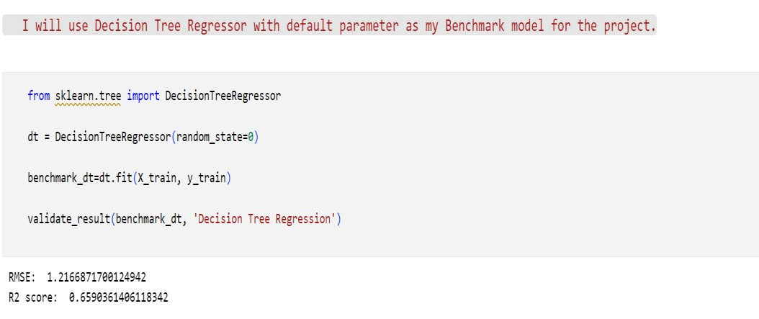
Fig:5.1, Decision Tree Regression

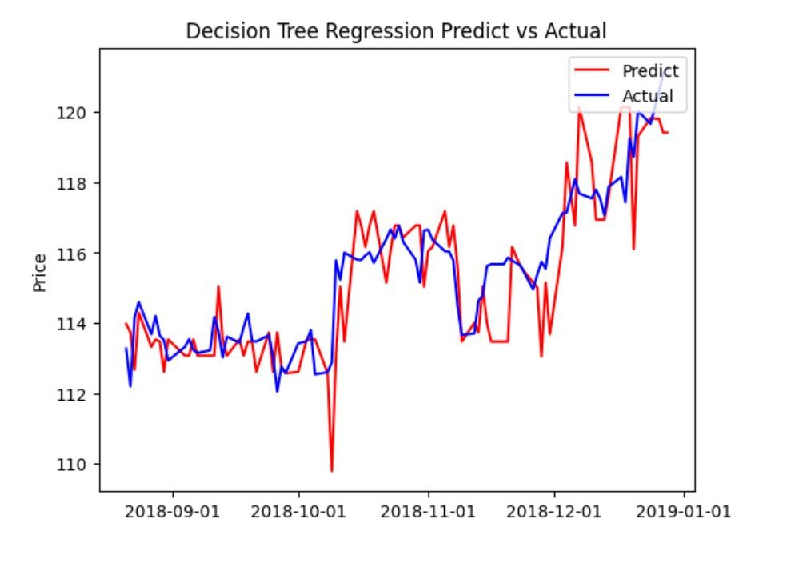
Fig:5.2, predictive vs actual

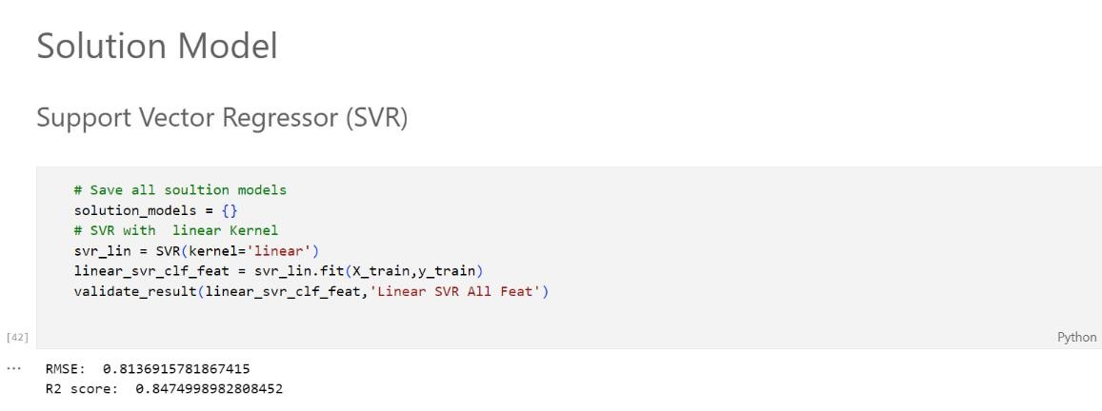
Fig:5.3, support vector regression(SVR)

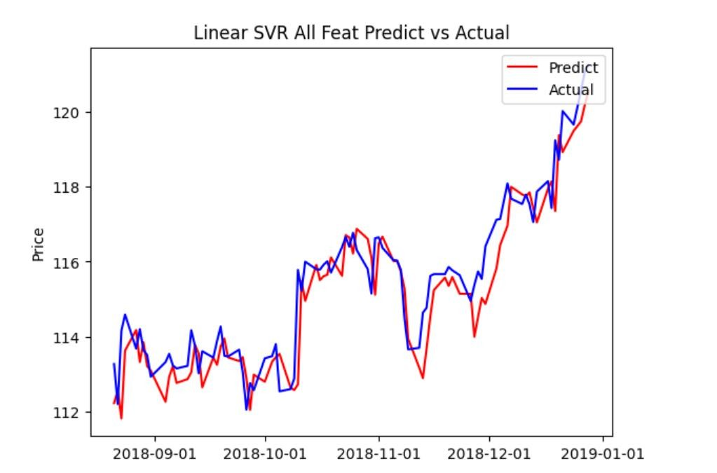
Fig:5.4, liner SVR
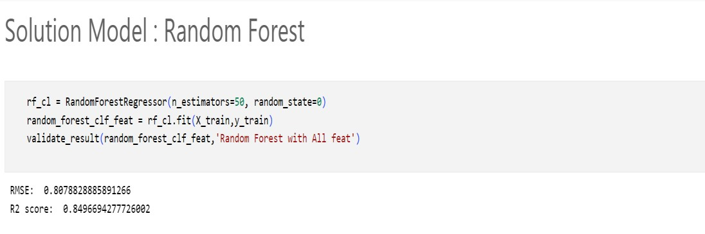
Fig:5.5, Random forest
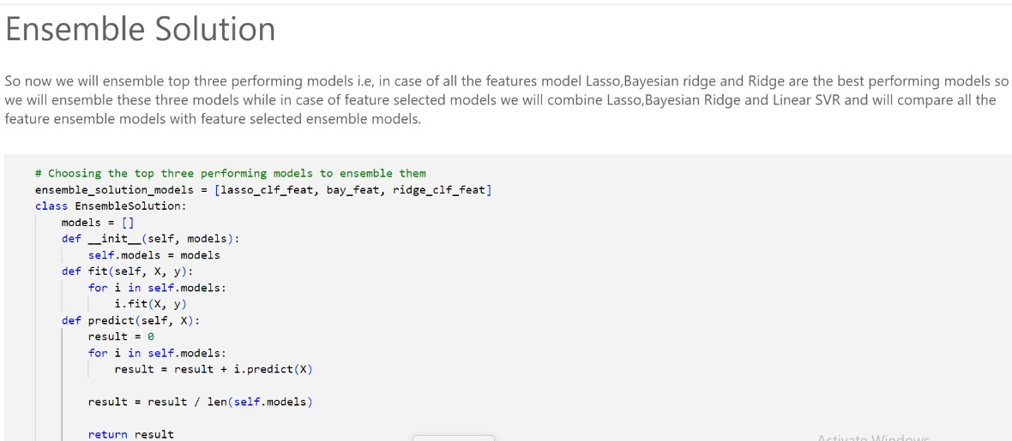

Fig:5.6, Ensemble model

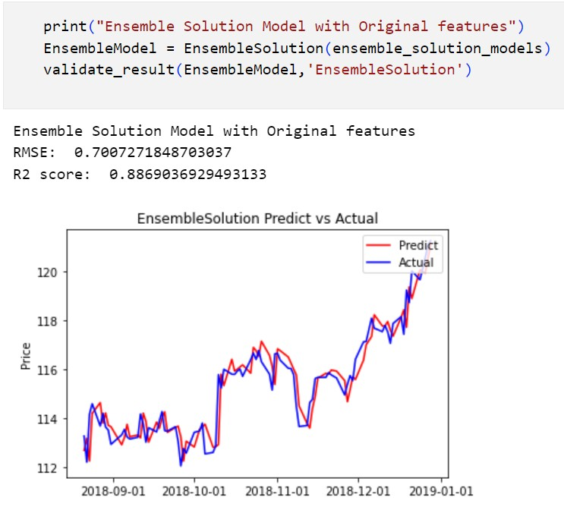
Fig:5.7, Ensemble solution predict vs actual
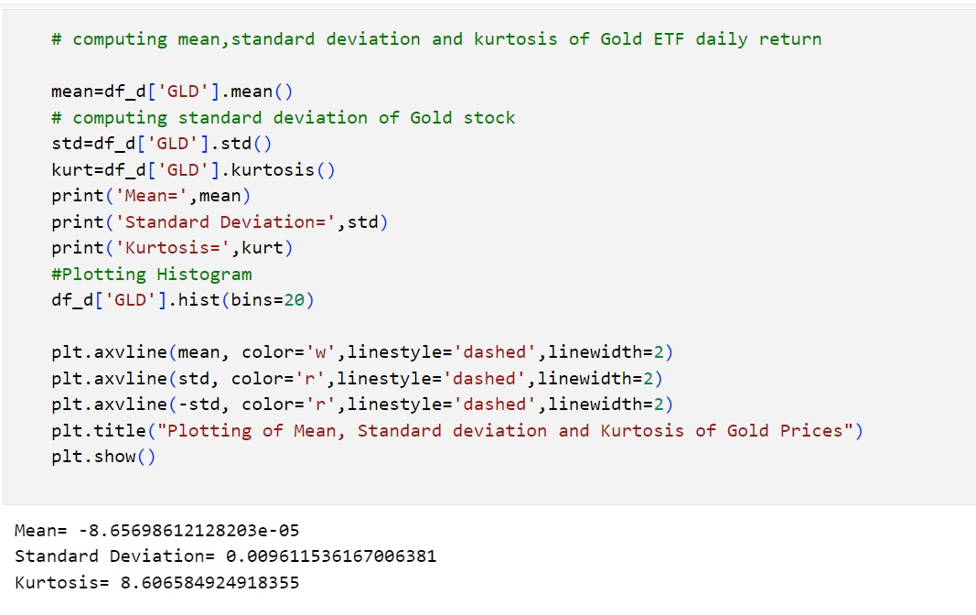
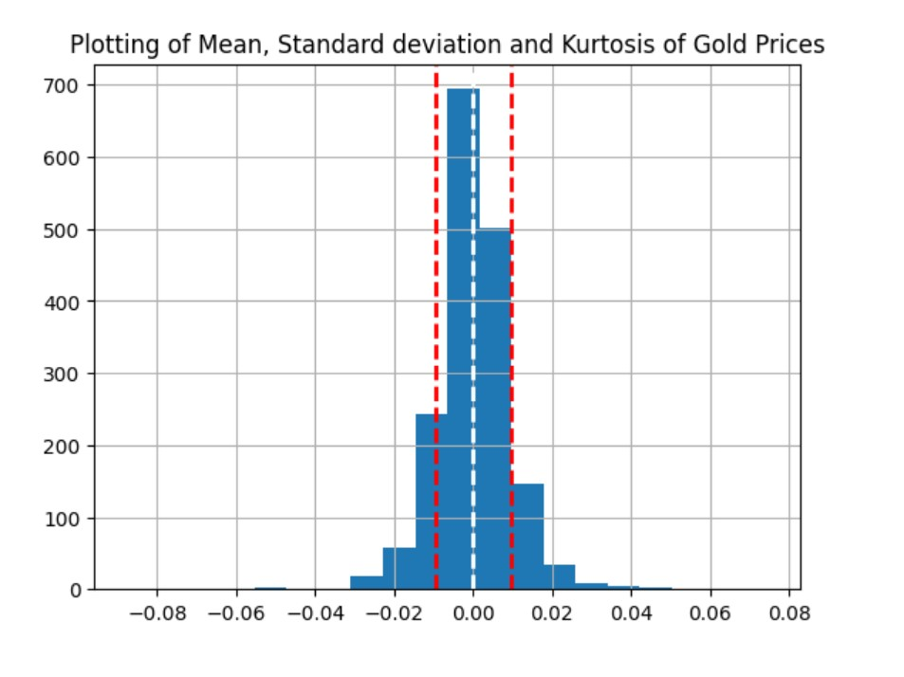
Fig:5.8, standard deviation and kurtosis of gold prices
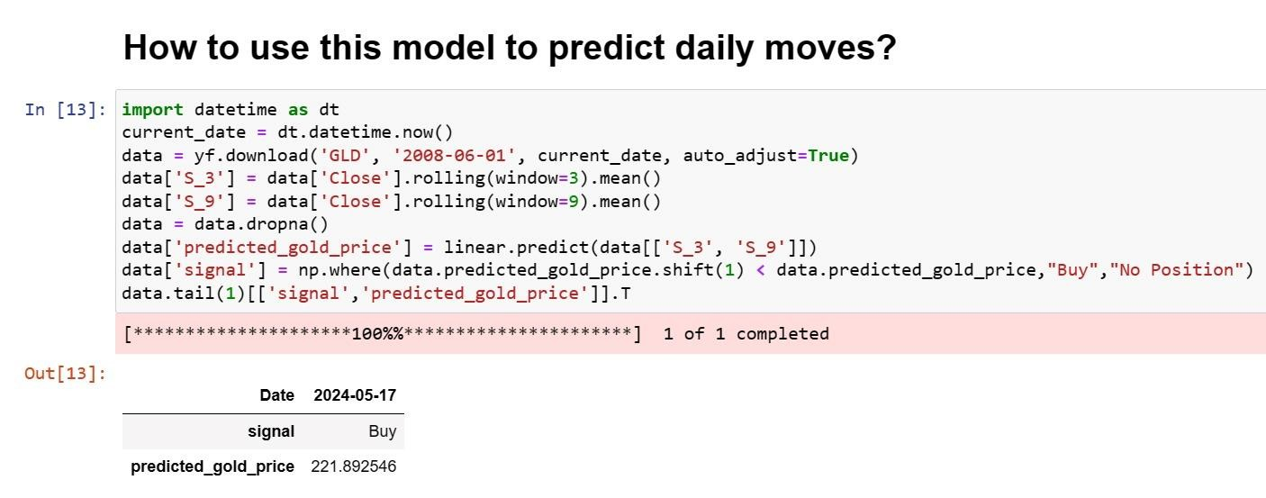

Fig:5.9, model of prediction

7.CONCLUSION

Using RandomForestRegressor for predicting gold prices has shown promising results, offering a robust and interpretable approach to forecasting. Here's a summary of the conclusion and potential future directions for improving gold price prediction. RandomForestRegressor has demonstrated its effectiveness in predicting gold prices based on historical data and relevant features.
- The model's ability to capture non-linear relationships and interactions among features makes it well-suited for modeling the complex dynamics of gold markets.
- Through feature importance analysis, the model provides insights into which factors contribute most significantly to gold price movements, aiding in decision-making and risk management strategies.
- Evaluation metrics such as Mean Absolute Error (MAE), Mean Squared Error (MSE), and R-squared have indicated the model's performance and its ability to generalize to unseen data.
- Gold has been one of the most important commodities throughout history. Maintaining gold reserves by central banks is crucial to support the current economic structure of theworld.
- Some major companies and investors also invest a hugeamount of money in gold.Although not easy, predicting the rate of gold would help investors and central banks to better decide when to sell and buy it, thus maximizing their profits.
- In this study, we used machine learning algorithms to predict the gold rates very accurately. Our study is also the most comprehensive to date, thus taking into consideration various economic indicators of various countries and companies.
- It is the first time that the stock value of major gold trading/producing companies, and Russia’s interest rates, have been successfully used as an indicator for forecasting of gold rates.
- To the contrary we show that stock value of a major company has more influence on the gold rates than US economy.In future, we intend to improve our results by using ensemble learning, and deep learning.
- The gold price prediction project utilizing machine learning showcased the transformative potential of advanced predictive modeling in financial markets. - Through the application of linear regression, support vector machines, and recurrent neural networks, the project demonstrated substantial improvements in forecasting accuracy.
- The LSTM model, in particular, excelled by effectively capturing temporal dependencies and integrating macroeconomic variables, which proved crucial for enhancing prediction reliability.
- Despite challenges such as data preprocessing, model tuning, and the computational demands of sophisticated algorithms, the project highlighted the importance of a comprehensive approach combining quantitative and qualitative analysis.
-The insights gained from this endeavor not only underscore the capability of machine learning to provide valuable predictions but also emphasize the need for ongoing innovation and integration of domain knowledge to address the complexities of financial forecasting.
- the gold price prediction project using machine learning underscored the remarkable capabilities and inherent challenges of leveraging advanced algorithms in financial forecasting. The implementation of various machine learning models, including linear regression, support vector machines (SVM), and long short-term memory (LSTM) networks, provided a robust framework for predicting gold prices with enhanced accuracy. The LSTM model stood out due to its proficiency in capturing complex temporal patterns and integrating external macroeconomic indicators, demonstrating a significant improvement over traditional methods.
- The project also highlighted the importance of rigorous data preprocessing, feature engineering, and hyperparameter optimization to achieve optimal model performance. Techniques such as cross-validation ensured the robustness and generalizability of the models, while ensemble methods offered a way to harness the strengths of multiple approaches for more reliable predictions.

8.FUTURE ENHANCEMENT

Feature Engineering: Further exploration and engineering of features related to macroeconomic indicators, geopolitical events, and market sentiment could enhance the model's predictive power.
Ensemble Methods: Experimentation with ensemble methods such as Gradient Boosting Machines (GBM) or stacking multiple regression models could potentially improve prediction accuracy by leveraging the strengths of different algorithms.
Time Series Modeling: Incorporating time series modeling techniques such as
Autoregressive Integrated Moving Average (ARIMA) or Long Short-Term Memory (LSTM) neural networks could capture temporal dependencies and seasonality in gold price data more effectively.
Model Interpretability: Enhancing the interpretability of the model by employing techniques such as SHAP (SHapley Additive exPlanations) values or Partial Dependence Plots (PDPs) would provide deeper insights into the factors driving gold price movements.
Real-Time Data Integration: Integration of real-time data feeds and sentiment analysis from social media platforms or news sources could enable the model to react promptly to market developments and adjust predictions accordingly.
Portfolio Optimization: Integration of gold price predictions into portfolio optimization strategies, considering risk-adjusted returns and asset allocation, could provide valuable insights for investors and fund managers.Overall, while RandomForestRegressor has shown promising results for gold price prediction, continuous refinement and exploration of alternative approaches are essential for improving prediction accuracy and robustness in real-world scenarios. By incorporating advancements in feature engineering,ensemble methods, time series modeling, interpretability, and data integration,the future outlook for gold price prediction using machine learning remains bright.
Future enhancements for gold price prediction using machine learning could involve several key advancements to further improve accuracy and applicability. One promising direction is the integration of more diverse data sources, such as real-time financial news, social media sentiment, and geopolitical event tracking, to capture a broader range of factors influencing gold prices.
Leveraging advanced natural language processing (NLP) techniques can help in extracting meaningful insights from these unstructured data sources. Additionally, the development of more sophisticated ensemble models that combine the strengths of various machine learning algorithms can offer more robust and reliable predictions.
Enhancements in real-time data processing capabilities and the implementation of streaming analytics will allow models to adapt to market changes instantaneously, providing up-to-date forecasts. Furthermore, advancements in explainable AI will be crucial, ensuring that models are not only accurate but also transparent and interpretable, which is vital for gaining trust from stakeholders.
Incorporating blockchain technology for secure and transparent data handling can also be explored to ensure data integrity. Finally, continuous model training and validation with the latest data will be essential to maintain the relevance and accuracy of predictions in the dynamic financial environment. These enhancements collectively aim to make gold price prediction models more comprehensive, adaptive, and reliable, ultimately supporting better decisionmaking in the financial sector.
In addition to the previously mentioned enhancements, future improvements in gold price prediction can benefit from the application of cutting-edge machine learning techniques like deep reinforcement learning and transfer learning. Deep reinforcement learning can be used to develop models that learn and adapt strategies based on the dynamic nature of the gold market, continuously improving from interaction with the environment. Transfer learning can facilitate the application of pre-trained models from related financial domains, reducing the need for extensive training data specific to gold prices and accelerating the development of robust predictive models.
Moreover, the incorporation of advanced feature selection methods such as genetic algorithms and principal component analysis (PCA) can help in identifying the most influential factors affecting gold prices, thereby improving model efficiency and accuracy. Implementing these methods can reduce dimensionality and enhance the interpretability of the models.

9.BIBLIOGRAPHY

- Breiman, L. (2001). Random forests. Machine learning, 45(1), 5-32.
- Liaw, A., & Wiener, M. (2002). Classification and regression by randomForest. R news, 2(3), 18-22.
- McKinney, W. (2010). Data structures for statistical computing in Python.
In
Proceedings of the 9th Python in Science Conference (Vol. 445, pp. 51-56). [4] VanderPlas, J. (2016). Python data science handbook: Essential tools for working with data. O'Reilly Media, In
- Pedregosa, F., Varoquaux, G., Gramfort, A., Michel, V., Thirion, B., Grisel, O., ... &Duchesnay, E. (2011). Scikit-learn: Machine learning in Python. Journal of machine learning research, 12(Oct), 2825-2830.
- Hunter, J. D. (2007). Matplotlib: A 2D graphics environment. Computing in science & engineering, 9(3), 90-95.
- McKinney, W., & Others. (2010). Data structures for statistical computing in
Python. In Proceedings of the 9th Python in Science Conference (Vol. 445, pp.
56-61).
- Waskom, M., et al. (2020). mwaskom/seaborn: v0.11.1 (January 2021).
Zenodo.
http://doi.org/10.5281/zenodo.3894937.
- Harris, C. R., Millman, K. J., van der Walt, S. J., Gommers, R., Virtanen, P., Cournapeau, D., ... & Wiebe, M. (2020). Array programming with NumPy.
Nature,
585(7825), 357-362.
- Oliphant, T. E. (2007). Python for scientific computing. Computing in science & engineering, 9(3), 10-20.
- Brownlee, J. (2016). Introduction to Time Series Forecasting with Python:
How
to Prepare Data and Develop Models to Predict the Future. Machine Learning Mastery.
- M. C. &. C.-C. C. Hsin-Hung Chen, "The Integration of Artificial
Neural Networks and Text Mining to Forecast Gold Futures Prices," Communications in Statistics - Simulation and Computation, pp. 1532- 414, 2016.
- H. Long, "http://money.cnn.com," cnn.com, 10 february 2016. [Online].
Available: http://money.cnn.com/2016/02/10/investing/china-gold/.
[Accessed 24 december 2016].
- P. V. M. V. P. G. M. P. Sima P Patel, "Gold Market Analyzer using
Selection based Algorithm," International Journal of Advanced Engineering Research and Science (IJAERS), vol. 3, no. 4, pp. 55-102, 2016.
- D. G. Navin, "Big Data Analytics for Gold Price Forecasting Based on
Decision Tree Algorithm and Support Vector," International Journal of Science and Research, pp. 2026-2030, 2015.

